***Requirements Errors – II***

***Lecture # 15***

***Today’s Topic and Recap***

* We discussed requirements errors in the last lecture
* Introduced different types of errors
* Discussed defect prevention
* Today we’ll talk about defect removal and in particular inspections using, perspective-based reading

***Defect Removal***

***Inspections***

* Inspections, by all accounts, do a better job of error removal than any competing technology, and they do it at a lower cost
  + **Robert Glass**
* Inspections are conducted by a group of people working on the project, with the objective to remove defects or errors
* Every member of the inspection team has to read and evaluate requirements documents before coming to the meeting and a formal meeting is conducted to discuss requirements errors
* Requirements errors detected during these inspections save lot of money and time as requirements errors do not flow into the design and development phases of software development process

***A complete description of inspections must address five dimensions:***

* + Technical
  + Managerial
  + Organizational
  + Assessment
  + Tool support

***Defect Detection Without Inspections***

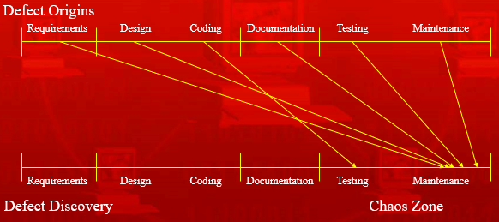

***Defect Detection With Inspections***

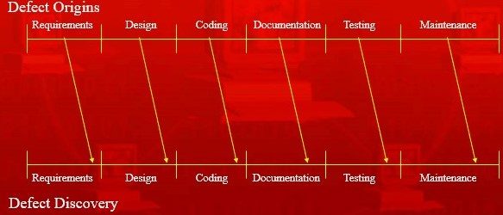

***Observations***

* Requirements engineers are trained to write requirements documents, but have no training on reading/reviewing requirements documents
* Reviewers typically rely on ad hoc reading techniques, with no well-defined procedure, learning largely by doing

***Techniques for Reading Requirements Documents***

* *Ad hoc review*
* *Checklist review*
* *Defect-based reading*
* *Perspective-based reading*

***Ad hoc Review***

* A review with no formal, systematic procedure, based only individual experience

***Checklist Review***

* A list of items is provided to reviewers, which makes this inspection process more focused

***Defect-based Reading***

* Provides a set of systematic procedures that reviewers can follow, which are tailored to the formal software cost reduction notation

***Perspective-Based Reading (PBR)***

* Researchers at Experimental Software Engineering Group at the University of Maryland, College Park, have created Perspective-Based Reading (PBR) to provide a set of software reading techniques for finding defects in English-language requirements documents

***Different Perspectives***

* PBR operates under the premise that different information in the requirements is more or less important for the different uses of the document
* Each user of the requirements document finds different aspects of the requirements important for accomplishing a particular task
* PBR provides a set of individual reviews, each from a particular requirements user’s point of view, that collectively cover the document’s relevant aspects
* This process is similar to constructing system use cases, which requires identifying who will use the system and in what way

***Steps in PBR***

* Selecting a set of perspectives for reviewing the requirements document
* Creating or tailoring procedures for each perspective usable for building a model of the relevant requirements information
* Augmenting each procedure with questions for finding defects while creating the model
* Applying procedures to review the document

***Two Questions***

* What information in these documents should they check?
* How do they identify defects in that information?

***Benefits of Different Perspectives***

***Systematic***

* + Explicitly identifying the different uses for the requirements gives reviewers a definite procedure for verifying whether those uses are achievable

***Focused***

* + PBR helps reviewers concentrate more effectively on certain types of defects, rather than having to look for all types

***Goal-oriented and customizable***

* + Reviewers can tailor perspectives based on the current goals of the organization

***Transferable via training***

* + PBR works from a definite procedure, and not the reviewer’s own experience with recognizing defects, new reviewers can receive training in the procedures’ steps

***Identifying Defects***

* A series of questions are used to identify different types of requirements defects
* Requirements that do not provide enough information to answer the questions usually do not provide enough information to support the user. Thus, reviewers can identify and fix defects beforehand

***Requirements Defects that PBR Helps Detect***

* *Missing information*
* *Ambiguous information*
* *Inconsistent information*
* *Incorrect fact*
* *Extraneous information*
* *Miscellaneous defects*

***Missing Information***

* Any significant requirement related to functionality, performance, design constraints, attributes, or external interface not included
* Undefined software responses to all realizable classes of input data in all realizable classes of situations
* Sections of the requirements document
* Figure labels and references, tables, and diagrams
* Definitions of terms and units of measures

***Ambiguous Information***

* Multiple interpretations caused by using multiple terms for the same characteristic or multiple meanings of a term in a particular context

***Inconsistent Information***

* Two or more requirements that conflict with one another

***Incorrect Facts***

* A requirement-asserted fact that cannot be true under the conditions specified for the system

***Extraneous Information***

* Unnecessary or unused information (at best, it is irrelevant; at worst, it may confuse requirements users)

***Miscellaneous Defects***

* Other errors, such as including a requirement in the wrong section

***Benefits of PBR’s Detailed Questions***

***Allow controlled improvement***

* + Reviewers can reword, add, or delete specific questions

***Allow training***

* + Reviewers can train to better understand the parts of a representation or work product that correspond to particular questions

***PBR General Questions***

* + Does the requirement make sense from what you know about the application or from what is specified in the general description?
* Do you have all the information necessary to identify the inputs to the requirement? Based on the general requirements and your domain knowledge are these inputs correct for this requirement?
* Have any of the necessary inputs been omitted?
* Are any inputs specified that are not needed for this requirement?
* Is this requirement in the appropriate section of the document?

***Results of PBR Experiments***

* PBR provides a framework that represents an improved approach for conducting requirements reviews
* This approach will only be effective when an organization tailors the framework to its own needs and uses feedback from its reviewers to continually improve and refine the techniques
* PBR seems best suited for reviewers with a certain range of experience.
* Development teams that use PBR to inspect requirements documents tend to detect more defects than they do using other less- structured approaches
* Relatively novice reviewers can use PBR techniques to apply their expertise in other development tasks to defect detection
* Using PBR improves team meeting by helping team members build up expertise in different aspects of a requirements document
* It creates high-level representations of the software system, usable as a basis of work products in later stages of the development
* Each development organization can customize PBR’s set of perspectives, level of detail, and types of questions
* PBR facilitates controlled improvements, providing a definite procedure, alterable according to projects metrics and reviewers’ feedback

***Summary***

* Discussed defect removal and in particular inspections using, perspective-based reading